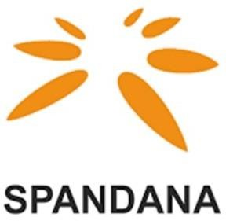

Interest rate

“The below interest rates are applicable from 01/09/2024”

|  |  |  |  |  |
| --- | --- | --- | --- | --- |
| **Product Name** | **Minimum Interest Rate offered currently* (%)** | **Maximum Interest Rate offered currently* (%)** | **Weighted Average interest rate of for last quarter\*\*** | **Average Processing Fees for last quarter** (% of the loan)** |
| Microfinance loans | 19.75 % | 24.75 % | 24.93 % | 1% + GST |

*Interest rates are calculated on a reducing balance basis per annum.

**Weighted Average interest rate & average processing fee displayed is for Q1FY25.